Bio 219: Techniques in Molecular Biology Sec# 065 Group# 5
Kristofer James
Elizabeth Rush
Chloe Segui
Amy Thai

Development of Genomic Library and Restriction Map of lux Containing Plasmid in A. fischeri.

Abstract
Aliivibrio fischeri is a marine organism that exhibits bioluminescence, a light emitting process caused by aldehyde encoded by the lux operon. Luciferase and reduced riboflavin catalyze increase luminescence. pGEM-3zf(+) is the ideal host for chDNA uptake because it is small enough to be contained in the cell and yields multiple DNA copies. We isolated the chDNA using a DNeasy Mini Spin Column, along with 2 wash buffers and centrifugation for purification. We analyzed the isolation using a spectrophotometer, which showed high DNA concentration with slight salt contamination. Sal I was used to cut the pGEM vector and the obtained chDNA. The recombinant DNA is then expected to ligate back together via their sticky ends. Gel Red was used in gel electrophoresis to cause fluorescence in areas containing DNA because of its tendency to bind to nucleic acids. We successfully obtained a digested pGEM vector at 3.68 kb as well as a successful A. fischeri digestion. Both lambdas have 32 kb and 15 kb bands, and thus Sal I was properly acting as a restriction enzyme. For ligation of chDNA into pGEM, we used ratios of chDNA insert “free ends” to vector DNA “free ends” in order to test which ratio of insert to vector gave the best ligation of the insert into the vector. For our experiment, we used ratios of 4:1, 3:1, 2:1, and 1:1. Each ratio had ligated DNA in our results, but 2:1 and 1:1 ratios had the best ligations because L1:1₀ and L2:1_{ligated} had 2 digested pGEM vectors.

Introduction
The purpose of this entire project is to essentially create a genomic library of Aliivibrio fischeri as well as creating a restriction map of the lux containing plasmid. Understanding what bioluminescence is and how it works is crucial to this experiment. The lux operon is a necessary set of proteins for the luminous effects of bioluminescence to occur (9). Bioluminescence is a light emitting processes done without heat and is also used to recognize and mediate problems (3). It has been studied that bioluminescence is great for marine species hunting luminous bacteria, however the same cannot be said conversely. The benefits of bioluminescence for bacteria is still unknown (3). Luciferase, aldehydes, and reduced riboflavin phosphate (FMNH2) are three considerable aspects of bioluminescence. First, the basic function of luciferase is to act as a catalytic enzyme for luminous reactions (4). The significant subunits in luciferase are the alpha and beta subunits that arose from duplication (4). The alpha subunit has an active site with unknown roles for the amino acids in or near the site. The beta subunit is needed for light emission and interactions between the enzymes and the reduced flavin (3).
Secondly, the main role of aldehydes is facilitated through a fatty acid reductase complex involving a reductase, a transferase, and a synthetase encoded by lux C, lux D, and lux E respectively (4). Bioluminescence requires a natural aldehyde for light emission to work properly. The natural aldehyde used is a tetradecanal, usually longer chains are best for high levels of luminosity (3). Lastly, reduced riboflavin phosphate (FMNH2) is another significant element studied to be very specific for luciferase. Plainly removing a phosphate group can modify the luminous activity by lessening it (3). The only things that are then capable of restoring activity are either adding high concentrations of a phosphate/sulfate, or a substitution of a carboxyl group (3). A. fischeri is the model organism that is being used in this experiment. It is a gram negative bacteria that is rod shaped. Like most bioluminescent organisms, A. fischeri is also found in marine environments (9). A. fischeri is a clade that is part of the Vibrionaceae and not all of these bacterial species have a yellow-shifted luminosity (1). A. fischeri is also known as a phylogenetic structure which resembles variation in the host species or differences in the ecological incidence of strains (1). This means that A. fischeri deals with the evolutionary development of its kind.
Aside from the entire purpose of the project, the focal point to this paper is to show how chromosomal DNA was isolated from an A. fischeri sample to obtain the lux operon. There are many reagents that were used to isolate chDNA. A mix of resuspension buffer, proteinase K, Rnase A, Lysis Buffer, Ethanol, 2 was buffers, and DNA grade water were used. The binding of nucleic acids was performed with ethanol and the addition of a lysis buffer to intensify the hydrophobic effect (9). Proteinase K was used to help defuse enzymes that disrupt nucleic acids while RNase was used to defuse RNA to have the DNA stay undamaged (9). Within the buffer included sodium dodecyl sulphate (SDS), a strong anionic detergent used to help solubilize the membrane proteins (9). DNA binding proteins are released through SDS facilitation by debasing them and binding both membrane and non-membrane proteins as monomers (9). Spin columns are similar to microcentrifuge tubes, except for the fact that spin column can be used to extract material while the microcentrifuge tubes cannot. Once all the reagents were aliquoted into the mini spin column, SDS created a cation bridge to bind DNA to the silica portion of the spin column (9). The wash buffers were used in the final steps to attempt to minimize any salt contamination. Using a spin column to isolate the salt from the collected DNA was efficient and less time-consuming, thus best for the short duration given for the project.
After the DNA was acquired, a spec analysis was conducted with the aid of a NanoDrop to observe how pure of a DNA concentration was taken from A. fischeri. According to the Beer-Lambert Law, the absorbance of chDNA is used in an equation that makes the absorbance equal to the path of light to determine the concentration of DNA in the NanoDrop (9). The spectrophotometer was used because nucleic acids strongly take in ultraviolet (UV) light (9). A spectrophotometer functions by utilizing a light source that goes through the tube containing the experimental sample thus causing a wavelength of colors. Due to the nitrogenous base, at 260 nm DNA is within the UV range (9).
Once the chDNA is extracted and analyzed through the aforementioned spec analysis, restriction digestion follows. The process of restriction digestion is simply cutting the obtained DNA with a restriction enzyme in very specific areas (10). Performing this digest allows to better analyze the DNA. The restriction enzyme used was Sal I. From that, it is expected that the two fragments of recombinant DNA will then be ligated back together by the sticky-ends
For the process of cutting the chDNA and vector DNA a restriction enzyme was needed. The chDNA has the lux operon which is 8.5 kb. Thus, an enzyme that does not cut into the lux operon is necessary. Sal I is able to cut the chDNA in 9 kb which misses the 8.5 kb and gives a higher probability of intact operons. Also when Sal I cuts the DNA it leaves the fragment ends “sticky”, meaning that the top strand is cut at 3’OH group and the bottom strand is cut at 5’PO4. Therefore, the opposing strand must have the opposite cuts to make the strands able to connect. Other enzymes tend to have “blunt” ends that are not the best to ligate because they are cut straight down the middle making the binding process problematic.
Gel electrophoresis is a process which pushes inserted reagents from a negative end to a positive end depending on the size of the molecule (10). Since DNA and RNA have negatively charged backbones they are able to “run” from the negative to positive. The smaller the molecule the further it will run downwards and conversely for heavy molecules. In the gel, a 1 kb ladder was added as a legend to help identify the size molecules are. The gels were filled with the resulting chDNA and vector fragments that were digested by Sal I. Electrophoresis was done to study the digestion of the enzyme on those molecules by evaluating their size.
Ligation is the recombination of covalent bonds between DNA strands that are compatible. The recombination of chDNA and DNA is favored but it is not consistent. To minimize errors in the ligation of DNA ratios were computed to consider the possible outcomes. The ratios were based on an insert to vector scale. Meaning that for all the “free ends” found on the ends of chDNA fragments there’s a corresponding vector. The ratio that suitable for the test is a 3:1 ratio meaning that there are 3 inserts for every one vector. But the one problem with more free ends is that the fragments of chDNA can ligate on themselves instead of the vector DNA or the plasmid vector would reattach. Another possibility is that the vector takes up too much foreign DNA and is incapable of being engulfed by the host
A plasmid is a circular double-stranded molecule that is separate from chromosomal DNA and can be engineered to replicate DNA as a vector (2). A plasmid vector it’s comprised of various elements like a drug-resistant gene, a replication gene, and a site where insertion of DNA is placed. The pGEM-32f(+) is a vector that will intake the chDNA for transformation and further studies. The plasmid vector pGEM is able to withhold a good amount of foreign DNA while being small enough to be retained by the host (2). It is able to produce multiple copies of the DNA so its copy number is high. It has an origin of replication that enables the vector to yield multiple copies by using the host equipment. In the replication of host DNA there’s RNA polymerase promoter sequences embedded for mRNA construction. The RNA polymerase sequences has 2 promoters and able to code from any direction of the cloning site. The multiple cloning site is engineered to disrupt the lacZ gene that codes for a restriction enzyme to cut linear instead of breaking into fragments. To observe results the pGEM vector has Amp Resistance, which is a selectable marker, to convey if the DNA is in the vector. (10).
From observations of the restriction digestion we see prominent digestion of both chDNA and pGEM in the lanes contain Sal I. The size of pGEM is estimated 12kb and Sal I cuts on average 9 kb therefore digested pGEM should have a band size ranging around 3.2kb.Our Allivibrio fischeri DNA control did not show smearing as much as the digested Allivibrio fischeri containing Sal I.

Materials and Methods

Chromosomal DNA Isolation, Purification, and Spec Analysis
In order to obtain the lux operon from the Aliivibrio fischeri needed for the entire project, the chromosomal DNA must be isolated and purified from the A. fischeri sample. The first step in obtaining chDNA from A. fischeri is lysis of the phospholipid bilayer. The A. fischeri pellet was completely resuspended in 180 μL of the Resuspension Buffer (Buffer ATL) (QIAGEN, Inc., Valencia, CA). Then, 20 μL of Proteinase K (QIAGEN, Inc.) was added to the microcentrifuge tube and thoroughly mixed using a vortex. The microcentrifuge tube was incubated in a 56°C shaking water bath for one hour. After incubation, 4 μL of RNase A (100mg/ml) was added to the tube. The tube was then mixed by vortexing and incubated at room temperature for two minutes. Then, 200 μL of Lysis Buffer (Buffer AL) (QIAGEN, Inc.) was added to the tube and vortexed for thirty seconds. The second step was the binding of nucleic acids to silica using ethanol. 200 μL of 100% Ethanol was added to the tube and vortexed for thirty seconds. A DNeasy Mini Spin Column (QIAGEN, Inc.) was assembled by placing the column into a fresh 2.0 mL microcentrifuge tube. The mixture was aliquoted into the DNeasy Mini Spin Column and centrifuged at maximum speed for one minute. Afterwards, the flow through was carefully discarded. The third step in obtaining chromosomal DNA was washing the A. fischeri sample with two types of wash buffers. 500 μL of Wash Buffer 1 (AW1) (QIAGEN, Inc.) was added to the DNeasy Mini Spin Column and centrifuged at maximum speed for one minute. The flow through was then carefully discarded. 500 μL of Wash Buffer 2 (AW2) (QIAGEN, Inc.) was added to the DNeasy Mini Spin Column and centrifuged on maximum speed for three minutes. The flow through was again discarded and the washing step with Wash Buffer 2 (AW2) was repeated to ensure the removal of all contaminants. The flow through was discarded along with the collection tube. The DNeasy Mini Spin Column was placed in a new 1.5 mL microcentrifuge tube and air dried for ten minutes. The final step is the elution of the DNA from the silica using DNA Grade Water. After air drying the DNeasy Mini Spin Column for ten minutes, 75 μL of DNA Grade Water was added directly to the spin column membrane and incubated at room temperature for ten minutes. The DNeasy Mini Spin Column was then centrifuged at maximum speed for two minutes and the flow through contents were not discarded. The elution process was then repeated and the DNA was then ready for use and stored at -20°C. After the chromosomal DNA was isolated and purified from the A. fischeri sample, the DNA was analyzed for purity and concentration using the Nanodrop. (9).

Restriction Digestion
A crucial part of this lab is the restriction digestion of the A. fischeri chDNA and the pGEM plasmid vector (Promega Corporation, Madison, WI). The following steps will allow the chDNA to break into separate fragments that can be utilized for cloning. The digestion of the pGEM (Promega Corporation) plasmid vector will allow it to become linearized and take in chDNA fragments during the ligation process. Before doing the restriction digestions, the appropriate calculations needed to be formed. To calculate the volume needed for 1.0 µg of our chDNA (107.2 ng/μL nucleic acid concentration), the equation: (Concentration of chDNA)*(Volume of chDNA needed) = (Final Concentration of chDNA) was used. This was repeated for a 0.5 µg final concentration of chDNA, and a value of 4.3 µL of a 107.2 ng/µL chDNA was determined. Next, the calculations of the pGEM (0.2 µg/µL) for 1.0 µg and 0.4 µg of chDNA came out to be 5 μL and 2 μL respectively. The volumes of Sal I (10 u/µL) (Promega Corporation), H₂O, and TE buffer (µL) were calculated to correspond to the desired volume. In nine microcentrifuge tubes, the appropriate amounts of 10x Buffer, A. fischeri DNA, pGEM, Lambda (Promega Corporation), water, TE buffer, and Sal I were added. Three genomic digest tubes received A. fischeri DNA and Sal I. The negative controls for undigested chDNA in TE buffer also received A. fischeri DNA. The restriction of vector DNA tube, and the negative control tube representing undigested vector DNA received pGEM vector with Sal I, as well as pGEM vector with no Sal I. The positive control for digested Lambda and the negative control for undigested Lambda received Lambda DNA (Promega Corporation) with Sal I, and Lambda DNA with no Sal I. All nine tubes received 10x buffer along with the appropriate amount of water to achieve a total volume of 35 µL. After all the tubes were filled, making sure Sal I is added last, the contents are centrifuged for 30 seconds at max speed. The tubes were then placed inside a shaking water bath to incubate for 3 hours at 37°C. After the incubation was complete, the samples were stored at -20°C. (10).

Gel Electrophoresis
While the tubes were incubating, the next procedure was to prepare an 0.8% agarose gel for gel electrophoresis. In a 125 mL Erlenmeyer flask, 0.48 g of agarose and 60 mL 1X TAE buffer was added. It was then microwaved for 30 seconds with a 25-mL Erlenmeyer flask in the mouth of the 125 mL flask, until the agarose dissolved completely. When the agarose cooled to 60°C, 6 µL of Gel Red (GelRed™Nucleic Acid Gel Stain) (Biotium, Hayward, CA) was added and the mixture was poured into the Gel Doc (Bio-Rad Laboratories, Inc., Hercules, CA). A 12 tooth comb was inserted and removed once the gel was completely solidified. The agarose gel was turned so that the wells faced the negative anode of the Gel Doc, then 1X TAE Buffer was poured onto the gel in a fashion that covered the entire gel. After the incubation of the tubes was complete, 5 µL of each tube was transferred into 9 new tubes, and 1 µL of 6X loading dye was added. Additionally, two more tubes labeled “1 kb” were included for the 1 kb ladder (Biotium Inc.), and received 10 µL of the digestion. Each tube; except for the 1 kb tubes, was centrifuged for 30 seconds at max speed. Once the gels were ready to be loaded, wells 1 and 11 received 5 µL of the 1 kb ladder. Wells 2-10 received 6 µL from the 9 restriction digest tubes. The electrophoresis was then run at 140 V until the dye migrated ¾ of the way towards the end of the gel. Once the electrophoresis was complete, the gel was imaged using the Gel Doc EZ Imaging System (Bio-Rad Laboratories, Inc.). (10).

Ligation
The A. fischeri restriction fragments then needed to be ligated from the A. fischeri chromosomal DNA to the digested pGEM vector in order to generate a partial Genomic library containing a pGEM vector and a lux operon. Initially, all of the reagents were chilled in an ice bath. The Sal I digests of the A. fischeri chDNA as well as the pGEM-3zf(+) vector were heat-inactivated at 65°C for twenty minutes. Meanwhile, 4 sterile microcentrifuge tubes were obtained and labeled L1-L4. After all of the samples were heat-inactivated, the three of the genomic digests were combined into one genomic digest tube. In order to obtain the required concentration for each ligation, the required volumes of genomic digest, digested pGEM vector, and T4 Ligase (Promega Corporation) were calculated.The amounts of 2X Ligation Buffer (Promega Corporation) and water were calculated in order to determine how much was needed to achieve a final volume of 50 µL. The ligation buffer was then vortexed. Each component was added to the corresponding microcentrifuge tubes, which were labeled L1-L4, by first adding the water and the ligation buffer, then adding the digested pGEM vector and the genomic digest. However, T4 Ligase was not added until later in the lab. 10 µL of each microcentrifuge tube solution was removed and placed into four new sterile microcentrifuge tubes labeled L1₀-L4₀ and placed on ice. Then, the original four microcentrifuge tubes were centrifuged and T4 Ligase was added and mixed into each of the tubes by gently pipetting up and down. The tubes were incubated at room temperature for fifteen minutes. (Siegert, 2016). Next, another 0.8% agarose gel was prepared for the gel electrophoresis of ligation reactions between the A. fischeri chDNA and pGEM vector digests. Four microcentrifuge tubes were labeled L1_{end}-L4_{end}, in which 10 µL of the corresponding L1-L4 ligation reactions was transferred. Two µL of loading dye was added to each L1-L4 and each of the L1₀-L4₀ tubes as well. As the electrophoresis ran at 140 V, and bromophenol blue migrated ¾ of the way towards the end of the gel indicating its completion, the gel was then imaged and ready to be analyzed. (10).

Results

Sample | Nucleic Acid Conc [ng/μl] | A260 [nm] | A280 [nm] | 260/280 [nm] | 260/230 [nm]
1* | 107.2 | 2.143 | 1.187 | 1.81 | 1.82
2 | 51.4 | 1.028 | 0.571 | 1.8 | 1.78
Table 1. A. fischeri Chromosomal DNA NanoDrop Results. Spectrophotometric Analysis of chDNA with Absorbancy Values (measured at 260, 280, and 230 nm) Purity Ratios, and Final concentration of chromosomal DNA
*selected sample

After isolation of our chromosomal A. fischeri DNA in two separate samples, we ran a spectrophotometric analysis. We observed that Sample 1 had the most amount of chromosomal DNA with 107.2 ng/μl. We observed a value of 2.143 at a 260 nm absorption and 1.187 at 280 nm. We got 1.81 and 1.82 for the 260/280 and 260/230 nm absorption ratios respectively. For Sample 2, we observed a decrease in the amount of chromosomal DNA with only 51.4 ng/μl. A value of 1.028 at a 260 nm absorption and 0.571 at 280 nm was seen. For the 260/280 and 260/230 nm absorption ratios we got 1.8, and 1.78 respectively.

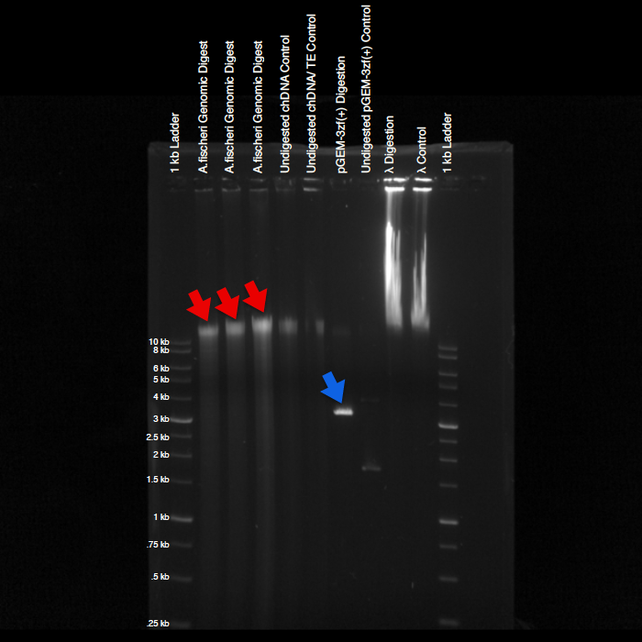
Figure 1. Agarose Gel Electrophoresis of Sal I Digested chDNA and pGEM Vector. Electrophoresis of agarose gel used to determine band sizes in relation to the 1 kb ladder and the migration of undigested and digested DNA in kb pairs. The fragment size observed for digested pGEM-3zf(+) was 3.68 kb (blue arrow). The digested A. fischeri chDNA had a range of 12.2 to 13.9 kb (red arrows).

Gel Lanes | Band Sizes ( kb)
A. fischeri Genomic Digest (1) | 12.25
A. fischeri Genomic Digest (2) | 12.81
A. fischeri Genomic Digest (3) | 13.93
Undigested chDNA Control | 12.94
Undigested chDNA/TE Control | 12.89
pGEM-3zf(+) Digestion | 3.68
Undigested pGEM-3zf(+) Control | 1.74
λ Digestion | 37.0, 13.88
λ Control | 37.0, 13.91
Table 2. Band Sizes of Agarose Gel Electrophoresis of Restriction Digestion. These are the band sizes of the corresponding chromosomal DNA, pGEM, and lambda that were calculated using a standard curve.
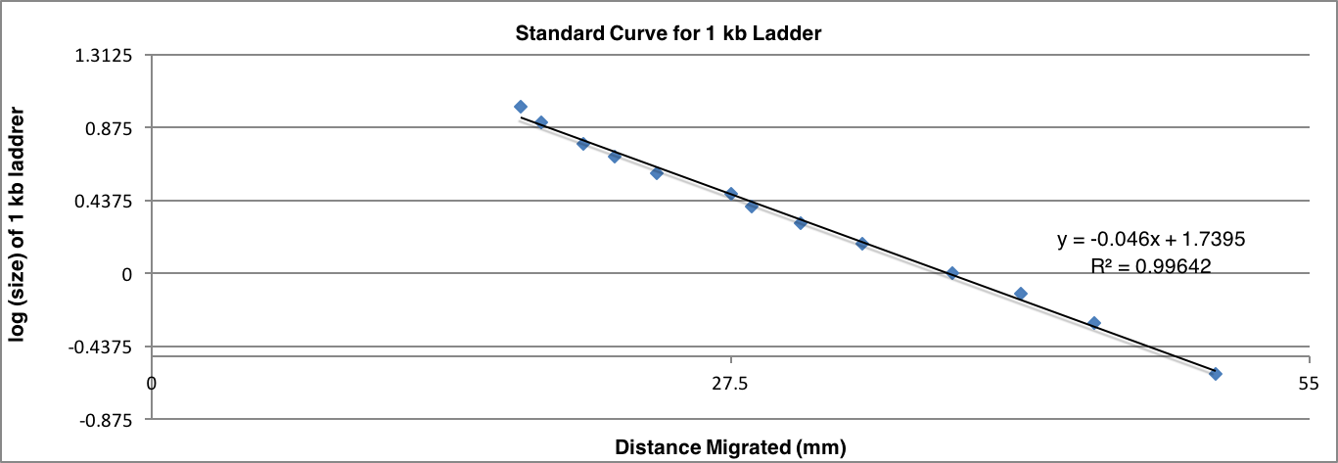
Figure 2. Standard Curve for 1 kb Ladder. Standard curve from a 1 kb ladder used for calculations of A. fischeri and pGEM-3zf(+) ligation digestion. The curve produced the equation: y = -0.046x + 1.7395 which was used to determine specific band sizes.

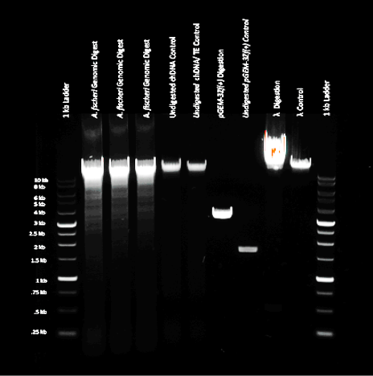
Figure 3. Example of a Good Restriction Digestion Gel. This is an example of a good restriction digestion gel that has complete digestion of chDNA and vector plasmid. (10)

The three triplicate genomic digests were digested with Sal I and produced a smearing pattern, revealing that the chDNA was degraded into fragments (Fig 1). After creating a standard curve by measuring the distance traveled for each band, we were able to produce the equation:
y = -0.046x + 1.7395; which allowed us to find the size of the bands measured in kilo bases (Fig 2). Each genomic digest (from left to right on Fig. 1) had fragment sizes of 12.25, 12.81, and 13.93 kb. The digested pGEM had a band size of of 3.68 kb (Table 2). Lambda cuts twice; the bands shown on the gel can be seen at 32 kb and 1 kb (Figure 1). When comparing Figure 1 and Figure 3, the results we achieved are similar to the good example of a restriction digest, therefore strengthening the validity of our results. Both images produced revealed similar and favorable smearing and the bands in both gels can be seen in comparable locations.

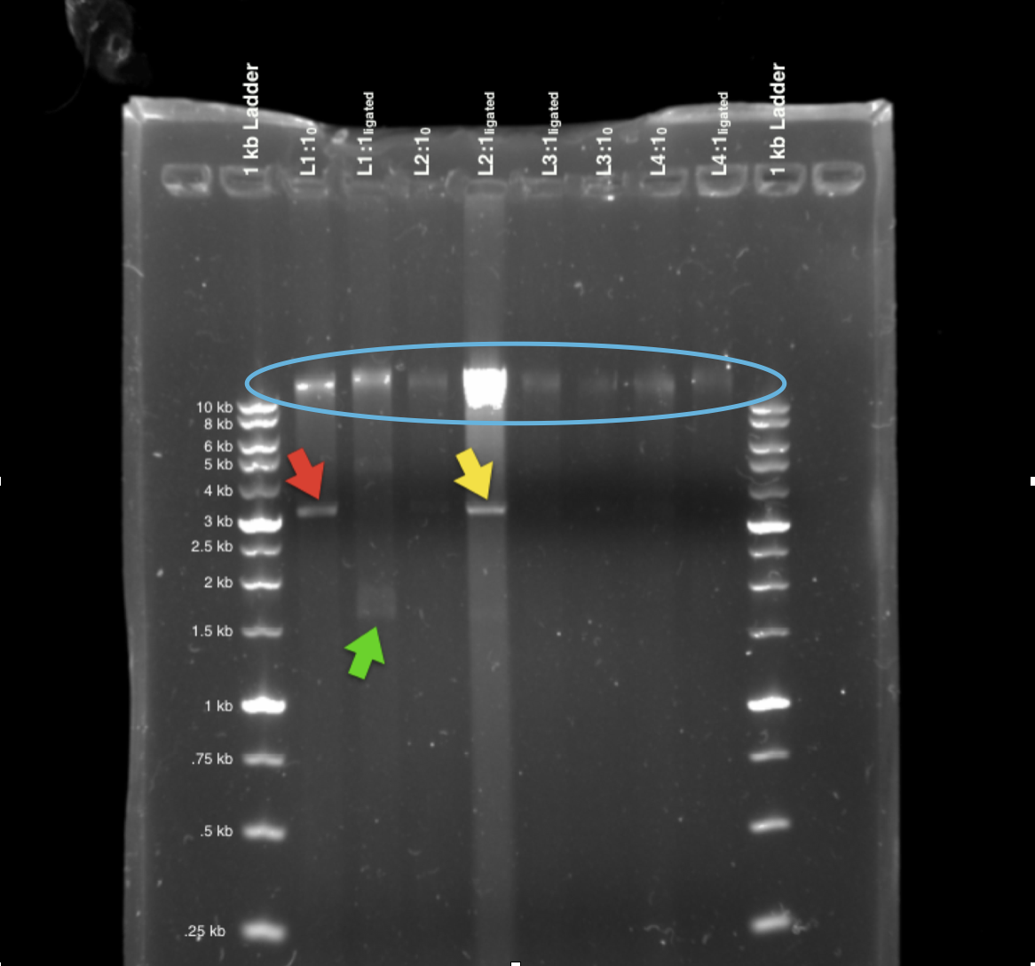
Figure 4. Agarose Gel Electrophoresis of Ligation of chDNA fragments to the pGEM vector. Agarose gel electrophoresis image utilizing band sizes from a 1 kb ladder in comparison to ligated and unligated DNA in kilobase pairs and their migration. All lanes had ligated chDNA with fragment sizes of 9.4 kb to 13.6 kb, marked with the blue oval. Digested pGEM-3zf(+) was observed in L1:1₀ (3.41 kb), marked with a red arrow, and in L2:1_{ligated} (3.49 kb), marked with a yellow arrow. A supercoiled vector that self-ligated was observed in L1:1_{ligated} (1.76 kb), marked with a green arrow.

Gel Lanes | Band Size ( kb)
L1:1₀ | 13.2, 3.41
L1:1_{ligated} | 14, 1.76
L2:1₀ | 13.6
L2:1_{ligated} | 9.4, 3.49
L3:1₀ | 12.5
L3:1_{ligated} | 12.25
L4:1₀ | 12
L4:1_{ligated} | 12.3
Table 3. Band Sizes of Agarose Gel Electrophoresis of Ligation. These are the band sizes of the corresponding chromosomal DNA, pGEM, and lambda that were calculated using a standard curve.

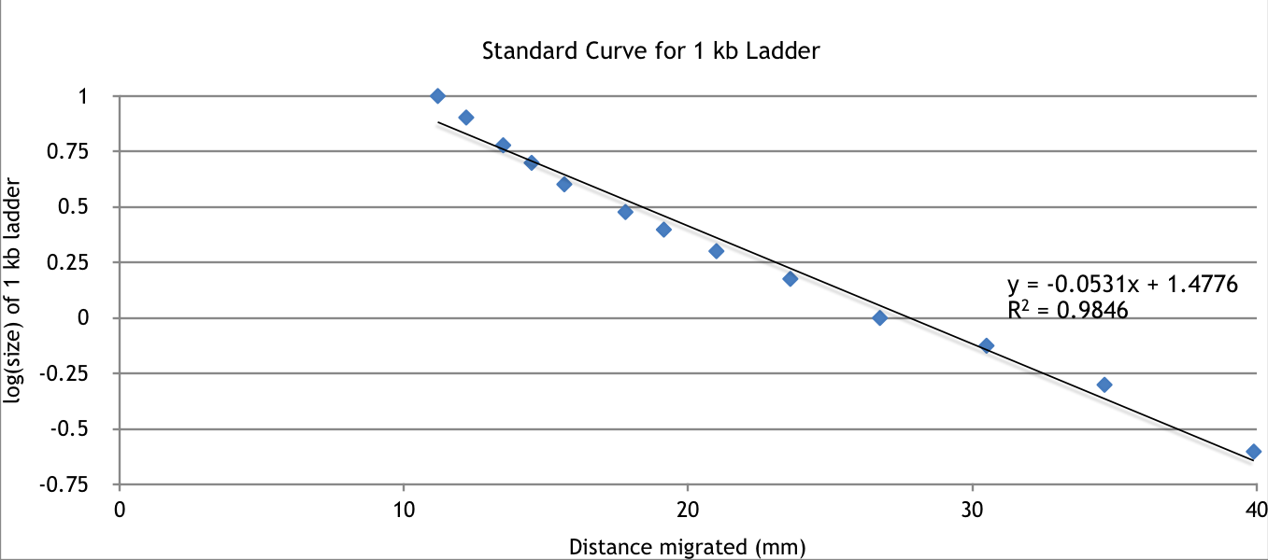
Figure 5. Standard Curve for 1 kb Ladder. Standard curve from a 1 kb ladder used for calculations of digested A. fischeri and pGEM-3zf(+) ligation. The curve produced the equation: y = -0.0531x + 1.4776 which was used to determine specific band sizes.
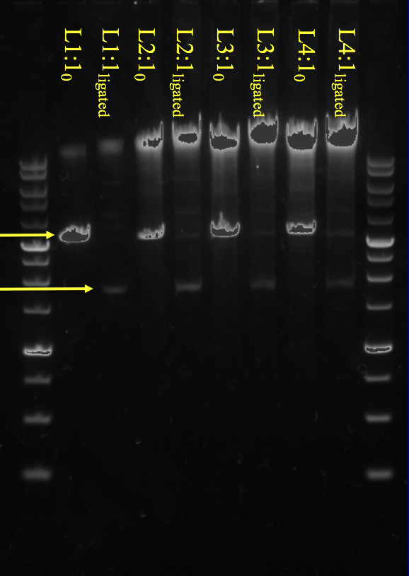
Figure 6. Example of a Good Ligation Gel. This is an example of a good ligation gel that contains digested pGEM-3zf(+) and self-ligated pGEM-3zf(+) (yellow arrows). (12)

Our ligations provided satisfactory results for the digested pGEM-3zf(+) and the chromosomal DNA, as seen in the gel image (Fig. 3). All of the lanes produced bands, ranging from faint to bold, that show ligated chromosomal DNA into the vector. However, there was no significant decrease in intensity between the control and the ligated chDNA. The chDNA bands observed in all lanes did not have significant smearing. By creating a standard curve by measuring the distance traveled for each band, we were able to plot a line of best fit with the equation: y = -0.0531x + 1.4776; this allowed us to calculate the measured band sizes in kilo bases (Fig. 4). The digested pGEM-3zf(+) in L1:1₀ (3.41 kb) and L2:1_{ligated} (3.49 kb) were observed (Fig. 3). A supercoiled vector that ligated to itself without a chDNA fragment (1.76 kb) was also observed (Fig. 3). In Figure 6, the important things to consider are the digested pGEM-3zf(+) and self-ligated pGEM-3zf(+). When comparing our gel (Figure 4) to Figure 6, the digested pGEM-3zf(+) and self-ligated pGEM-3zf(+) can also be seen in lanes in L1:1₀ and L1:1_{ligated}, which reflects positively on our results.

Discussion
As aforementioned, the purpose of this entire project is to create a genomic library of Aliivibrio fischeri and create a restriction map of a lux containing plasmid as well. To obtain chromosomal DNA from A. fischeri, a chDNA Isolation and Spec Analysis was done. This process entailed retrieving DNA and analyzing it through a spectrophotometer for a detailed analysis on the acquired A. fischeri DNA. A significant part of this process involved the use of spin columns. A DNeasy Mini Spin Column with all the required reagents, including SDS, created a cation bridge to isolate and bind DNA to the silica portion of the spin column (9). Purification was possible through the wash buffers and multiple centrifuging cycles (9). The purification process involved two wash buffers. The first was used in an attempt to clarify the acquired DNA from proteins and other contaminants with chaotropic salt. The second wash buffer was used to further purify by removing the salt contamination by the first wash buffer (9). The entire purification process was done by placing the spin column in new collection tubes after each wash buffer (9). Our results showed a relatively high concentration of DNA in comparison to salt contamination. The best DNA concentration obtained was 107.2ng/μl with a salt contamination of 1.82 in sample 1. Although the DNA was not completely pure of salt, it was still very pure in comparison to the amount of salt. The found results indicate that the DNA was mostly pure. According to a study done on microbial DNA extractions, pure DNA usually lies between 1.7 and 2.0 (14). The sample of DNA showed 1.80 of 260/280 protein and RNA contaminants. This means that the first wash buffer functioned as it should have and cleared all the proteins and other non-DNA components adequately. If there was any sign of contamination, then another procedure could be done such as the dehydration and precipitation method done with the use of NaCl solution (5). This method was used in a research paper about the process of salting out DNA extractions. The results were conclusive to that of phenol chloroform extractions by consistently yielding 1.8 to 2.0 of 260/280 ratios (5).
The next step that followed is restriction digestion which is simply cutting the obtained chDNA from A. fischeri into different fragment sizes averaging up to 9 kb with a restriction enzyme named Sal I in very specific areas (10). Completing this digest allows to further analyze the DNA. From that, it is expected that the two fragments of recombinant DNA will then be ligated back together by the sticky ends. Gel Red is a strain of nucleic acid usually seen in the electrophoresis process (10). This material allows for fluorescent lighting to appear under ultraviolet lighting because of it’s high affinity to bind to nucleic acids (17). This means that fluorescence will appear in areas containing DNA where Gel Red is present. Post staining with Gel Red can amount to sensitivity and erases the possibility of the red dye to interfere negatively with DNA migration (17). Gel Red is a substitution for ethidium bromide because of its low toxicity level even at concentrations above the ones used for gel staining (17). Looking at the all the lanes displayed on the digestion gel in Figure 1, the presence of Gel Red is evident due to the fact that the lanes are showing fluorescent activity in DNA containing lanes. The lanes show bright fluorescence that aided in analyzing the entire gel clearly. For a restriction digest to work properly, Sal I has to be able to do its job and cut the chDNA that was obtained in the isolation process as well as the pGEM vector. The blue arrow in Figure 1 locates the digested pGEM vector. It appears at the 3.68 kb mark and is very bright. The fact that it is at the 3 kb mark and higher up on the gel than the undigested control next to it shows that the vector was cut successfully. A successful digest is supposed to be as shown in Figure 1; the undigested control ran further down the gel because it is supercoiled. This means that the digested control should show an opposite reaction and not run as far down the gel since it was cut, thus is not supercoiled but rather has less tension due to Sal I. When referring to the red arrows in Figure 1, the digested A. fischeri sample shows successful digestion because the bands also did not run down as far as the undigested control. The red bands all stayed at around the 10 kb mark. All the controls used include undigested chDNA, undigested chDNA/TE, undigested pGEM, and a lambda control. They were all used in comparison to the digested factors in the discovering the success of the digestion. The lambda DNA is linearized DNA that is 48.5 kb long (8). These lambda controls have a smeared band that helped interpret results. Both the digested and undigested lambda are found above the 10 kb mark, thus indicating that Sal I was working well as a restriction enzyme because the bands were higher up on the gel just as the digested pGEM and chDNA. Sal I aids in the success of cloning because it recognizes the high GC basepairs. The high amount of GC base pairs in Sal I alongside the low amount of GC base pairs seen in A. fischeri guarantees that Sal I will cut A. fischeri less often (10). Cutting into A. fischeri less often is a great thing because the lux operon is 8.5 kb long. The lambda controls have two Sal I cut sites at 32,745 bp and 33,244 bp to check if Sal I is working properly (10). The two cut sites indicate that lambda and Sal I should show three fragments of different size DNA on the gel. The three different sizes should be 32 kb, 0.5 kb, and 16 kb. Figure 1, shows that the 0.5 kb fragment of the lambda control ran off the gel because it was too small of a fragment for the gel used for this experiment. A 0.8 agarose gel retains longer fragments instead of smaller ones. This is why the other two longer fragments can be seen towards the top of the lambda control.
The volume for all vectors was 3.5uL. The chDNA fragments concentration differs between ratios. The 0.1ug of vector DNA has 6 free ends while one insert of chDNA is 0.1ug and it has 2 free ends so multiplying the chDNA concentration of 3 gives 6 free ends on insert so that it’s receptive to the 6 ends of 0.1ug vector. The self-ligation of the pGEM3zf(+) shows the ability of the vector ligating back and the possibility of taking in chDNA. We are able to distinguish the presence of ligation occurring because we know that Sal I cuts on average every 9 kb and the controls are 12 kb therefore to identify if the pGEM is digested the remaining band size should be around 3 kb. In our case, L2 and L1 has digested bands with a 3.2 kb size shown in Figure 4(12).
Sal I is known to cut on average 9 kb fragments, cutting at the 5’ phosphate group and 3’ hydroxyl group, which gives probability of making the lux operon obtainable. The ligation procedure enables us to obtain the lux operon in a vector. The reason for T4 Ligase is because of the necessity of the “sticky ends” created by the restriction enzyme, Sal I. T4 Ligase needs a 3’OH and phosphate to initiate litigation (16).
The ligation of vector DNA to chDNA was observed and tested through a method of comprised ratios. These ratios were based off of the “free ends” of an insert to vector. “Free ends” are essentially a product of Sal I cutting the DNA into fragments leaving the ends “free”. The ratio serves the purpose of how many “free ends”of the insert and vector. For example a ratio 3:1 meaning that 3 “free ends” of the chDNA is being compared to 1 “free end” of the vector DNA. The ratios we used for the study were 4:1, 3:1, 2:1, and 1:1. We needed to use these specific ratios because we had three times the amount of chDNA than pGEM. Thus, by having ratios with increasing amounts of chDNA and keeping the pGEM amount the same, we were able to conserve the pGEM for the four ratios. In general, increasing the ratios would increase the number of free ends with would lead to more inserts ligating into vectors and less likelihood of pGEM ligating to itself, but also more likelihood of the vectors ligating to themselves. The ligation gel gave prominent results in the 2:1 and 1:1 ratio because of the 2 digested pGEM vectors in L1:1₀ and L2:1_{ligated}. A plasmid vector is used for the study because various elements are implemented in the actual vector to study certain aspects of the chDNA (2). The reason for choosing the pGEM-3zf(+) vector is because it is able to intake a large quantity of chDNA while still being able to be retained from host.
To isolate DNA, we used a method that involves lysing the cell membrane and use resuspension buffer, that is a detergent containing sodium dodecyl sulphate, with Proteinase K and RNase A to denature and remove proteins and RNA. Next, it is binded to ethanol to precipitate nucleic acids in our spin-columns. It is spun down by a centrifuge to obtain contaminants from the solution. The issues with this method is that salt contamination is not fully withdrew from the spin-columns. Also very short molecules of DNA are produced from ethanol(15).Another method of extracting DNA can be phenol-chloroform(organic)(15).The procedure still follows suite but instead of the enzymes stripping the proteins and RNA its being suspended in a solution of phenol-chloroform. This methods yields pure molecular DNA and very pure. The problems that are relative to this method is the amount time needed, hazardous chemicals and high risk of contamination.
To sum up the procedures done and results, the experiment started with a spec analysis on the isolation of chromosomal DNA from A. fischeri. The spec analysis showed satisfactory results of pure chDNA since the 260/280 ratio was 1.80. This number, 1.80, falls within the range of, 1.7 and 2.0, pure DNA (14). The chDNA had to then get cut by a restrictions enzyme. The enzyme used for this experiment was Sal I. Sal I helped cut the chDNA and vector into fragments that would enable ligation between the two. Since Sal I cuts on average every 9 kb and the controls are 12 kb, recognizing whether the pGEM was digested means making sure that the remaining band size be around 3 kb. In our case, L2 and L1 has digested bands with a 3.2 kb size as shown in Figure 3. The ligation procedure was done with the help of T4 Ligase and enabled us to obtain the lux operon.

Conclusion
Our experiment was able to show positive enzyme restriction and ligation of our plasmid vector, pGEM-3zf(+)in the 2:1 and 1:1 ratios. The A. fischeri chDNA molecules traveled at 10 kb and smeared in the Sal I gel seen in Figure 1. The next two molecules were negative controls without any enzymes meaning no digestion. The next molecule was pGEM-3zf(+) digestion which is the Sal I enzyme with the vector that traveled to the 3.2 kb line because of its size. The undigested pGEM-3zf(+) control had an undigested enzyme that traveled to the 1.75 kb. The last two lanes are Lambdas, one with Sal I labeled lambda Digestion and one without Sal I labeled control. They both seemed to travel to the same level.With Sal I being able to cut our DNA into fragments permits the stages of ligation by T4 Ligase.Sal I leaves over hangs on the ends of fragments that are bounded by a phosphodiester bond produced by T4 Ligase(16). In the event of ligating,ratios were created to favor a insert to vector formation.The number of free ends of chDNA depends on the amount concentrated needed for a certain ratio. The vector DNA concentration will always be 0.1μg which is a volume of 3.5μL.The ligation gel in Figure 4 shows working ligation happening in our 1:1 and 2:1 ratio from the strong smeared bands.Our results concluded that The process of DNA extraction could pose an error on how pure it is.The change in the volume of A.fischeri and pGEM-3zf(+) DNA can affect the results of ligation in positive ways. More tests are needed to be fulfill acquiring a genomic library and transformation of the bacteria.

References
- Ast, Jennifer C., Henryk Urbanczyk, and Paul V. Dunlap. "Multi-gene Analysis Reveals Previously Unrecognized Phylogenetic Diversity in Aliivibrio."Systematic and Applied Microbiology 32.6 (2009): 379-86. Web.
- Lodish, Harvey. DNA Cloning with Plasmid Vectors. U.S. National Library of Medicine, 2000. Web. 05 Oct. 2016.
- Meighen, E. "Enzymes And Genes From The Lux Operons Of Bioluminescent Bacteria." Annual Review of Microbiology 42.1 (1988): 151-76. Web.
- Meighen, Edward A. "Molecular Biology of Bacterial Bioluminescence." American Society of Microbiology 55.1 (1991): 123-35. Print.
- Miller, S A, D D Dykes, and H F Polesky. “A Simple Salting out Procedure for Extracting DNA from Human Nucleated Cells.” Nucleic Acids Research 16.3 (1988): 1215. Print.
- Nature.com. Nature Publishing Group, n.d. Web. 05 Oct. 2016.Zumbo, Paul. "Ethanol Precipitation." ETHANOL_PRECIPITATION (n.d.): n. pag.
- Nybo, Kristie. "BioTechniques - Cloning Efficiency." BioTechniques - Cloning Efficiency. BioTechniques, Nov. 2011. Web. 20 Oct. 2016.
- Roy, Nilanjan, et al. "The mcm17 mutation of yeast shows a size-dependent segregational defect of a mini-chromosome." Current genetics 32.3 (1997): 182-189.
- Siegert, K. 2016a. Isolation of chromosomal DNA. Bio 219 Laboratory Handout. Drexel University, Philadelphia, PA.
- Siegert, K. 2016b. Restriction Digestion. Bio 219 Laboratory Handout and Lab Slide. Drexel University, Philadelphia, PA
- Siegert, K. 2016c. Transformation. Bio 219 Laboratory Handout. Drexel University, Philadelphia, PA
- Siegert, K. 2016d. Ligation. Bio 219 Recitation Handout and Lab Slide. Drexel University,Philadelphia, PA
- Siegert, K. 2016e. Plasmid Mini Preps and Restriction Digestion. Bio 219 Recitation Handout. Drexel University, Philadelphia, PA
- Yeates, C., et al. "Methods for microbial DNA extraction from soil for PCR amplification." Biological procedures online 1.1 (1998): 40-47.
- Zumbo, Paul. "Phenol-chloroform Extraction." Phenol-chloroform Extraction (n.d.): n. pag. Http://physiology.med.cornell.edu/. Weill Cornell Medical College. Web. 2 Nov. 2016.
- "DNA Ligation." Addgene: Protocol. N.p., n.d. Web. 03 Nov. 2016.
- "FAQ: GelRed™ and GelGreen™ Nucleic Acid Gel Stains - Biotium." Biotium. N.p., n.d. Web. 02 Nov. 2016.
- Http://physiology.med.cornell.edu/. Weill Cornell Medical College. Web. 2 Nov. 2016.

